ANUKEERTHANA S

Module 4 - Test driven development and Logging framework
Mockito exercises
Exercise 1: Mocking and Stubbing
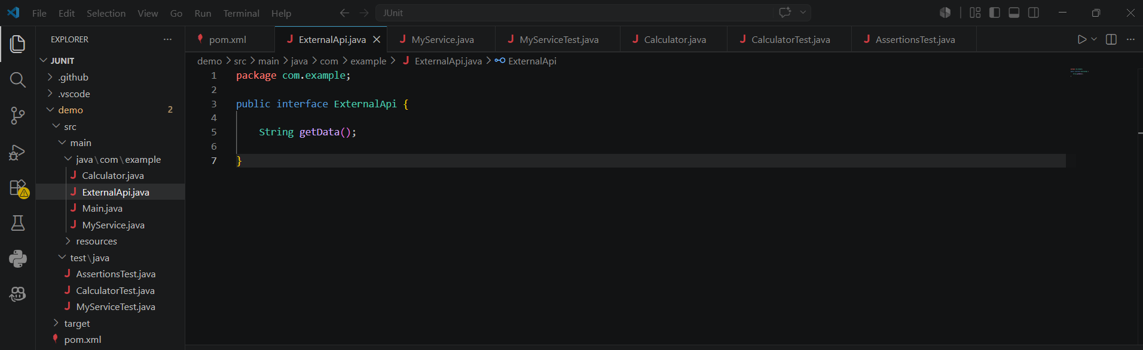

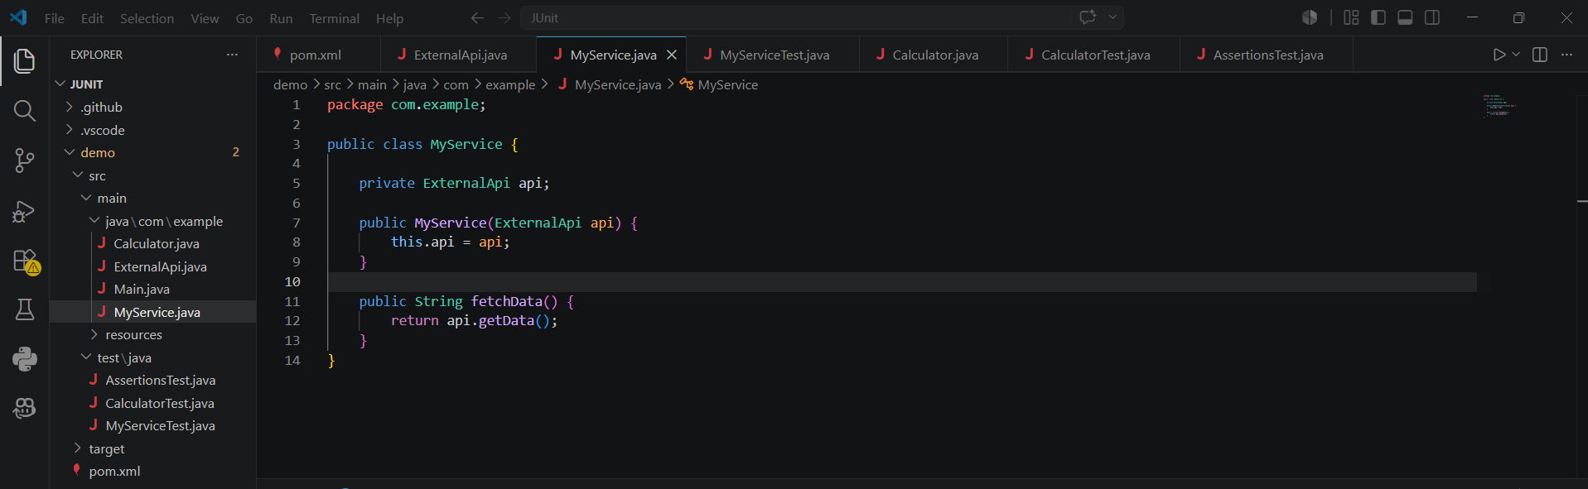
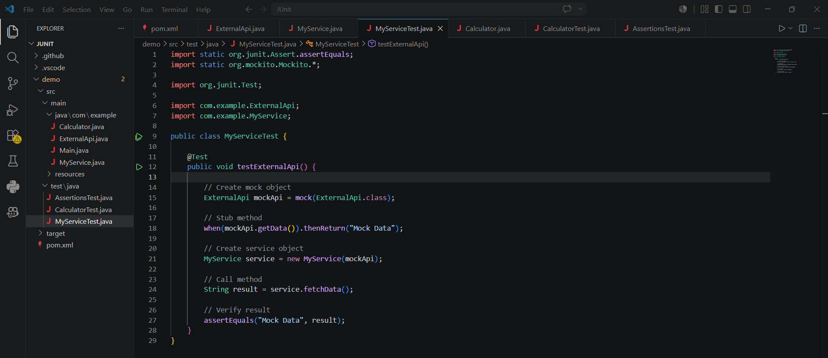
Output
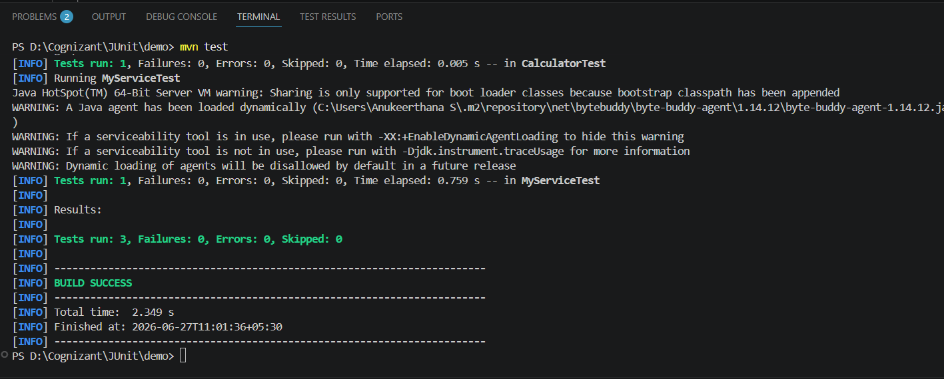

Exercise 2: Verifying Interactions
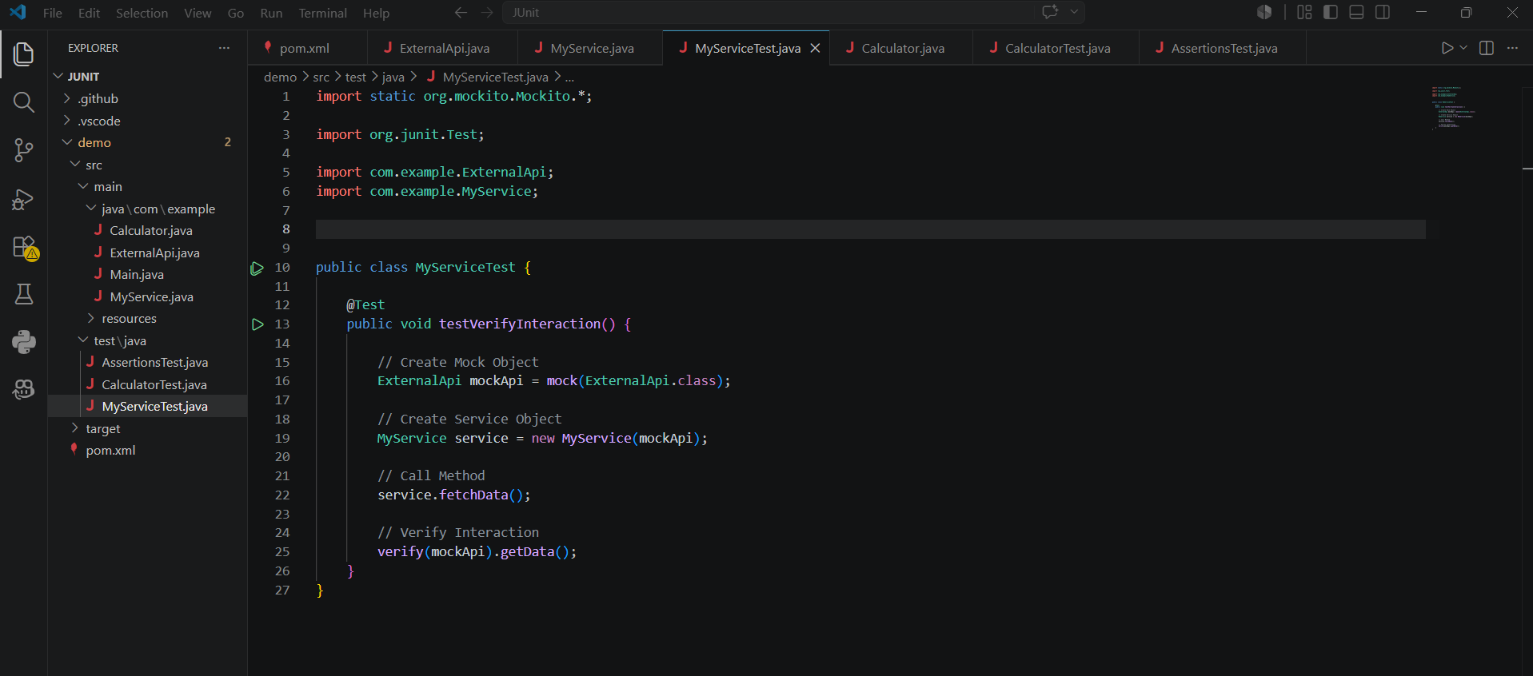
Output:
